# Querying the Dimensional Model (Corrected)

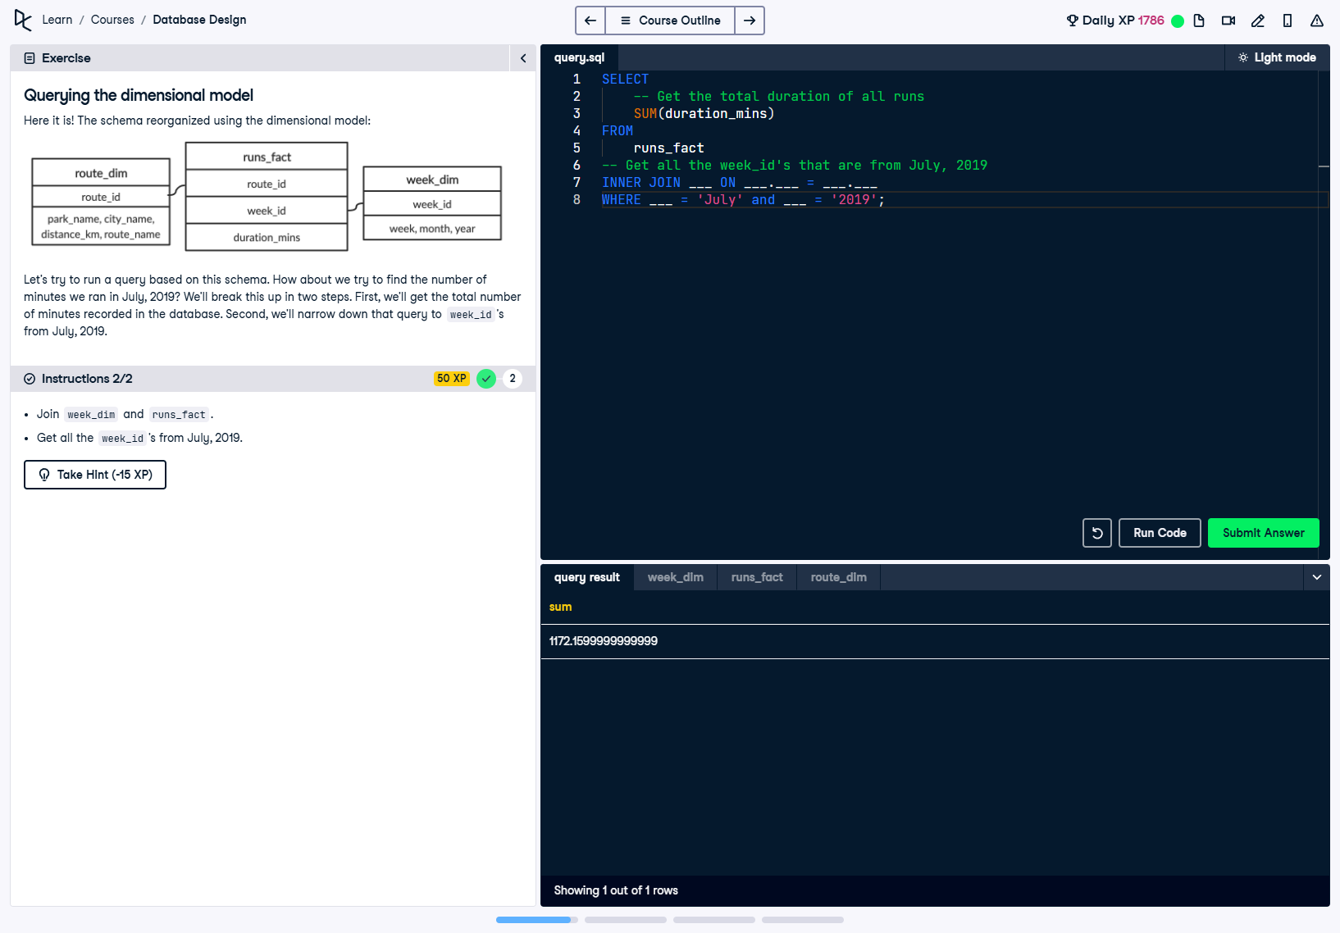

## Question

Here it is! The schema reorganized using the dimensional model:  
- route_dim: Contains details about the route (park name, city name, distance, and route name).  
- runs_fact: Contains facts such as duration_mins and foreign keys (route_id and week_id).  
- week_dim: Contains details about the week (week_id, week, month, and year).  
  
Let's try to run a query based on this schema. How about we try to find the number of minutes we ran in July, 2019?

## Corrected SQL Solution

SELECT   
 -- Get the total duration of all runs  
 SUM(duration_mins)  
FROM   
 runs_fact  
-- Get all the week_id's that are from July, 2019  
INNER JOIN week_dim ON week_dim.week_id = runs_fact.week_id  
WHERE month = 'July' AND year = '2019';

## Answer Explanation

In this query:  
1. **SUM(duration_mins):** Calculates the total duration of all runs by aggregating the 'duration_mins' column.  
2. **INNER JOIN:** Combines the 'runs_fact' table and the 'week_dim' table using the 'week_id' column as the key, ensuring the query has access to both tables' data.  
3. **WHERE Clause:** Filters records to include only those where the 'month' is 'July' and the 'year' is '2019', narrowing down the data to the desired time period.